20/04/20
THM 415: Finance
Quiz 2 Answer Sheet
- After graduating from university last fall with a major in Accounting and Finance, Jamel Ben Chafra took a job as an analyst trainee for an investment company in Ankara. His first few weeks were filled with a series of rotations throughout the firm’s various operating units, but this week he was assigned to one of firm’s traders as an analyst. On his first day, Jamel Ben’s boss called him in and told him that he wanted to do some basic analysis of the investment returns of a hotel called Karakartal Holiday Village. Specifically, Jamel Ben was given the following month-end closing prices for the company covering the period running from February 2019 to February 2020:
a) Compute the monthly realized rates of return earned by Karakartal Holiday Village. (1 Point)
b) Calculate the average monthly rate of return for Karakartal Holiday Village using both arithmetic and geometric averages? (2 Points)
- Arithmetic Average = (-5.10 % + 24.26 % + 9.54 % + 9.12 % - 8.23 % - 17.39 % - 5.76 % - 29.14 % - 8.37 % - 9.41 % - 39.17 % - 8.29 %) / 12 = - 7.33 %.
- Geometric Average = ((1 -5.10 %) * (1 + 24.26 %) * (1 + 9.54 %) * (1 + 9.12 %) * (1 - 8.23 %) * (1 - 17.39 %) * (1 - 5.76 %) * (1 - 29.14 %) * (1 - 8.37 %) * (1 - 9.41 %) * (1 - 39.17 %) * (1 - 8.29 %))^{(1/12)} -1 = - 8.82 %.
c) If you were given annual rate of return data for Karakartal Holiday Village or any other company’s stock and you were asked to estimate the average annual rate of return an investor would have earned over the sample period by holding the stock, would you use the arithmetic average or geometric average of the historical rates of return? Explain the reason behind your choice? (1 Point)
Certainly the geometric average shall be chosen since this very average tracks changes in rates of returns over a period of time due to its accountability for the effect of compounding.
- You own a portfolio consisting of the following stocks:
Assume the risk-free rate is 3.00 % and the expected return on the market portfolio is 10.50 %.
- Calculate the expected return of your portfolio. (0.50 Points)
- Expected return (Portfolio) = (20 % * 16 %) + (30 % * 14%) + (15% * 20%) + (25 % * 12 %) + (10 % * 24 %) = 15.80 %.
- Calculate the portfolio beta. (0.50 Points)
- Beta (Portfolio) = (20 % * 1) + (30 % * 0.85) + (15% * 1.20) + (25 % * 0.60) + (10 % * 1.60) = 0.95.
- Plot the security market line on a graph. Plot the stocks from your portfolio on the same graph. (2 Points)
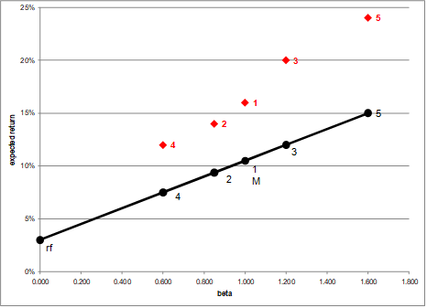
- From your plot in part c, which stocks appear to be your winners, and which ones appear to be losers? Explain the reason behind your conclusion. (2 Points)
This means that they are all offering higher expected returns than they should be, given their systematic risks. Thus, they are all underpriced. That’s why our portfolio’s expected return was higher than what was justified, given its beta. We have found five underpriced stocks!
- Why should you consider your conclusion in part d) to be less than certain? (1 Point)
Of course, this conclusion is based on our having the right betas. Recall that calculation of Betas are subjective (i.e. depend on the market to be chosen, sample size, time interval chosen, definition of period…). If all of our betas understate their stock’s systematic risks, then we would be underestimating our portfolio risk.
GOOD LUCK!

